Agora | Board Overview
3 Dec 2021 | v1.0

www.embeddedplanet.com

Contents
1. Introduction 3
2. Features 3
3. Feature Block Diagram 4
4. Development Software (mbed) 5
5. Development Hardware (Flidor) 5
6. Antenna Specifications 5
7. Customer Support 6
a. Contact Embedded Planet 6
b. Company Email 6

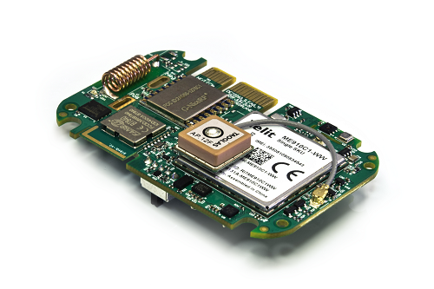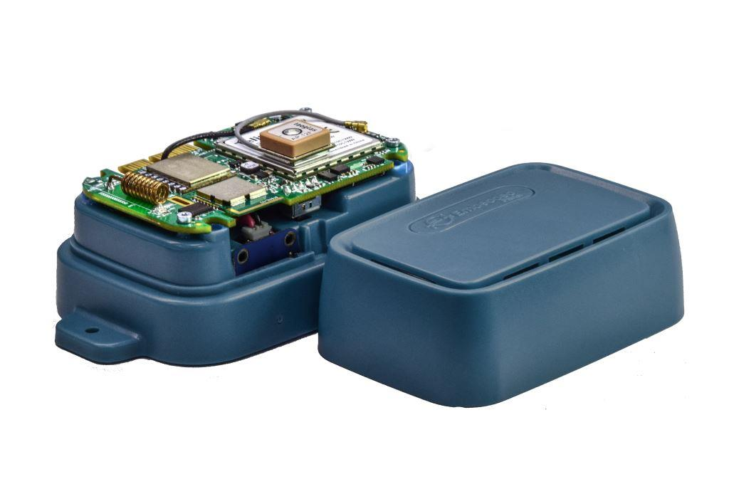
- Introduction
The Agora platform (EPM2M-AGORA-DEV) enables many applications including remote environment monitoring. Sensors include temperature, humidity, air quality, pressure, audio, inertial measurement, and range finding up to 2 meters. The platform also supports wireless data transport over BLE, LoRa, and/or Cellular (CAT-M1 / NB-IoT).
- Features
Agora's on-board features include the following:
Feature | Ref-Des | Description
Processor & BLE | U3 | Fanstel BT840 (nRF52840): Cortex M4F 32-bit processor. This is the application processor and facilitates Bluetooth connectivity
LoRa Module | U11 | NiceRF SX1276
Cellular Module | U12 | Telit ME910C1-WW [CAT-M1, NB-IoT]
6 axis IMU | U9 | ICM20602, I²C 6-Axis Integrated Linear Accelerometer and Gyroscope
9 axis IMU | U6 | LSM9DS1, I²C 9-Axis Integrated Linear Accelerometer, Gyroscope, and Magnetometer
Temperature and Humidity Sensor | U7 | Si7021-A10-GM(1)(R) - I²C Humidity and Temperature Sensor
Air Quality | U2 | BME680, Temperature, Humidity, Pressure, Air Quality
Time-Of-Flight ranging | U14 | VL53L0X, 2 m laser range finding IC
Microphone | U5 | ICS-43432, I²S Microphone for audio-event detection
NOR Flash | U1 | 25Q32JVIQ, 4MB external QSPI NOR Flash
Debug | TE1 | Tectonic Edge™ programming header
LED | LED1 | Red LED
Power | J6/BT1 | Connector for rechargeable LiPo battery, plated slots for battery solder tabs, and Tectonic Edge™ programming header

- Feature Block Diagram
The block diagram below is an overview of the Agora system. The development kit configuration comes populated with all sensor options & connectivity options as shown in the “PCB Populate Options” block. Application features of the processor are highlighted in the “Application Processor” block. The “Standard Options” block describes the items common to all Agora configurations. The items in the "Tectonic Edge™ Connector” block describe features accessible to the development kit through the Agora board edge connector. The “Common Cellular Modem” block highlights connectivity options for the modem.

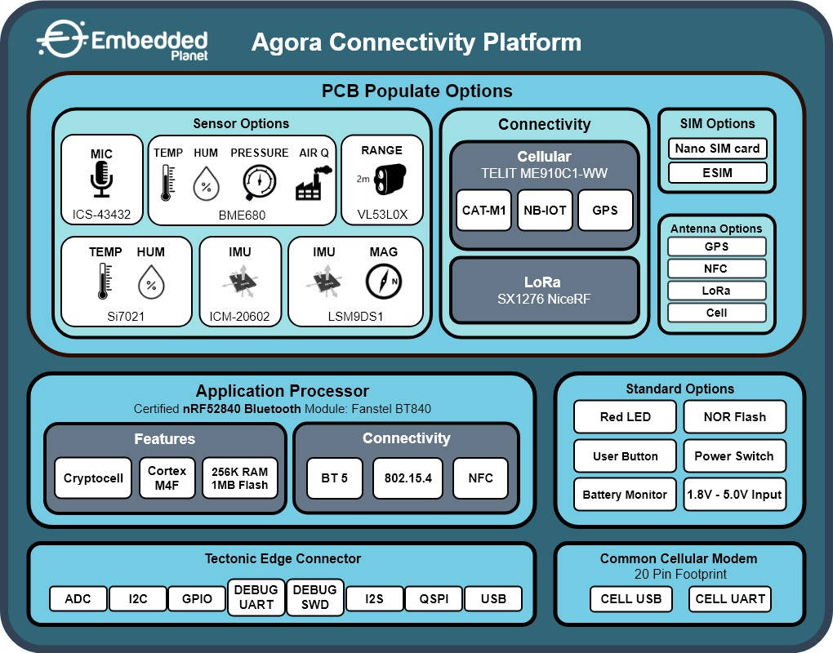

- Development Software (mbed)

For additional development information and tutorials, please visit the bed product page for the Agora Development Kit
https://os.mbed.com/platforms/agora-dev/

- Development Hardware (Flidor)

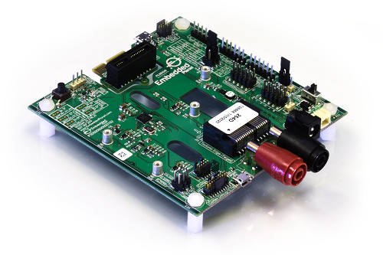
Agora application development requires the use of the Flidor development interface board. Flidor is a programmer, debugger, and breakout interface for Tectonic Edge™ compatible target devices designed by Embedded Planet such as Agora. Flidor provides adjustable power to the target MCU and connects it to a computer via USB for debugging in addition to its breakout capabilities.
Click here for more information about Flidor
Embeddedplanet.com/Flidor

- Antenna Specifications
Impedance: 50ohms
Input power: <24dBm (250mW)
VSWR (absolute maximum): 10:1 [above this limit, permanent damage to the module may occur]
VSWR (recommended maximum): 2:1 [to fulfill all regulatory requirements]
Recommended antennae: Taoglas MFX3.07.0150C
Minimum bandwidth, per LTE frequency band:​

- Customer Support
Embedded Planet provides complete support for our product line. Embedded Planet technical support includes product assistance for EP firmware and hardware. Technical support can assist with setup, installation, configuration, documentation, product related questions, and expansion guidelines.

  - Contact Embedded Planet
Embedded Planet
31225 Bainbridge Rd, Suite N
Solon, OH 44139
Phone:216.245.4180
Fax: 216.292.0561
www.embeddedplanet.com

  - Company Email
Sales: sales@embeddedplanet.com
Information Requests: info@embeddedplanet.com
Technical Support: support@embeddedplanet.com

Disclaimer

FCC NOTICE: This kit is designed to allow:

(1) Product developers to evaluate electronic components, circuitry, or software associated with the kit to determine whether to incorporate such items in a finished product and

(2) Software developers to write software applications for use with the end product. This kit is not a finished product and when assembled may not be resold or otherwise marketed unless all required FCC equipment authorizations are first obtained. Operation is subject to the condition that this product not cause harmful interference to licensed radio stations and that this product accept harmful interference. Unless the assembled kit is designed to operate under part 15, part 18 or part 95 of this chapter, the operator of the kit must operate under the authority of an FCC license holder or must secure an experimental authorization under part 5 of this chapter.

