Agora | Product Development Kit
3 Dec 2021 | v1.0.0

www.embeddedplanet.com

Contents
1. Introduction 3
2. Getting Started 3
a. Power Kit 3
b. Get Smartphone Application 3
c. View Agora Sensor Data 3
3. Next Steps: Example Applications 5
4. Kit Contents 5
5. Customer Support 7
a. Contact Embedded Planet 7
b. Company Email 7

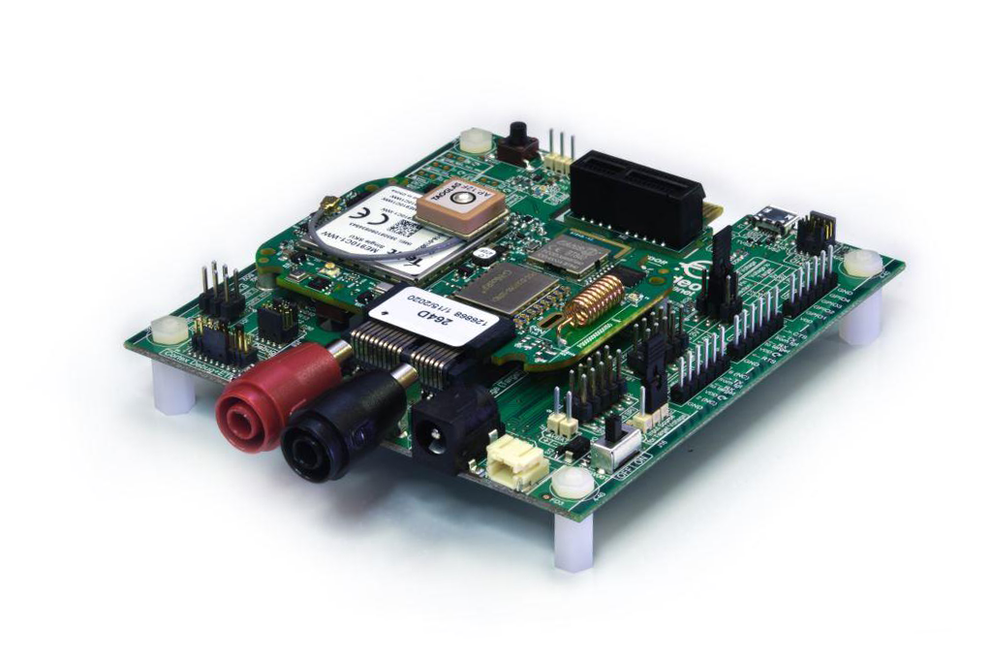
- Introduction
The Agora comes pre-loaded and ready to run the Bluetooth Low Energy (BLE) demonstration application. The following describes how to monitor the Agora sensors through a smartphone BLE test app.
https://github.com/EmbeddedPlanet/ep-agora-ble-reference-app
- Getting Started
  - Power Kit
Power the Flidor carrier board with the wall adapter connected to the barrel jack and set the carrier board slide switch to ON.
The status LED on the Agora will blink slowly indicating that the sensors on the board have initialized and the Agora is now advertising over BLE.
  - Get Smartphone Application
Load the Nordic nRF Connect App on a smartphone.
https://www.nordicsemi.com/Products/Development-tools/nrf-connect-for-mobile
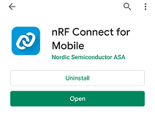
  - View Agora Sensor Data
Open the nRF Connect application on the smartphone, find the "EP Agora" in the list of devices being scanned and press connect.
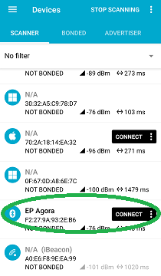
Once connected the status LED on the Agora will blink faster indicating that the Agora has connected to a peer over BLE.
The Agora sensors appear in the application as services; read data from the BME680 temperature sensor by selecting Unknown Service with UUID: 00000001-8dd4.....
Click on the down arrows to fetch data.
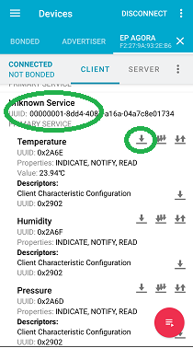
- Next Steps: Example Applications
Links to additional reference applications:
Name | Description
ep-agora-ble-reference-app | Bluetooth Low Energy reference application (used above)
mbed-os-example-blinky | Blinky Mbed OS example
mbed-os-example-cellular | Example cellular application for Mbed OS
mbed-os-example-lorawan | Example LoRaWAN application for Mbed OS
mbed-os-example-pelion | Pelion Device Management Client example for Mbed OS
mbed-os-example-ble | Example BLE applications for Mbed OS

- Kit Contents
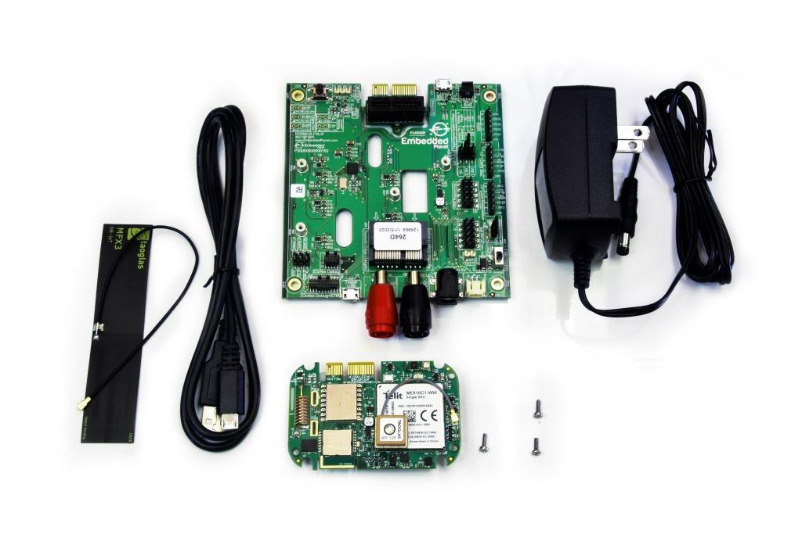Kit contains:
- Flidor carrier board
- Agora (pre-assembled to carrier)
- Power adapter
- USB-A to USB micro cable
- GPS antenna (pre-assembled to Agora)
- Cell antenna (pre-attached to Agora)
- Mounting hardware (pre-assembled carrier standoffs and Agora mounting)

Agora
Find out more about the Agora platform here:
https://www.embeddedplanet.com/agora/

Flidor
Find out more about the Flidor development board here:
https://www.embeddedplanet.com/product-documentation/flidor

- Customer Support
Embedded Planet provides complete support for our product line. Embedded Planet technical support includes product assistance for EP firmware and hardware. Technical support can assist with setup, installation, configuration, documentation, product related questions, and expansion guidelines.

  - Contact Embedded Planet
Embedded Planet
31225 Bainbridge Rd, Suite N
Solon, OH 44139
Phone:216.245.4180
Fax: 216.292.0561
www.embeddedplanet.com

  - Company Email
Sales: sales@embeddedplanet.com
Information Requests: info@embeddedplanet.com
Technical Support: support@embeddedplanet.com

Disclaimer

FCC NOTICE: This kit is designed to allow:

(1) Product developers to evaluate electronic components, circuitry, or software associated with the kit to determine whether to incorporate such items in a finished product and

(2) Software developers to write software applications for use with the end product. This kit is not a finished product and when assembled may not be resold or otherwise marketed unless all required FCC equipment authorizations are first obtained. Operation is subject to the condition that this product not cause harmful interference to licensed radio stations and that this product accept harmful interference. Unless the assembled kit is designed to operate under part 15, part 18 or part 95 of this chapter, the operator of the kit must operate under the authority of an FCC license holder or must secure an experimental authorization under part 5 of this chapter.

