Atlas Board Overview
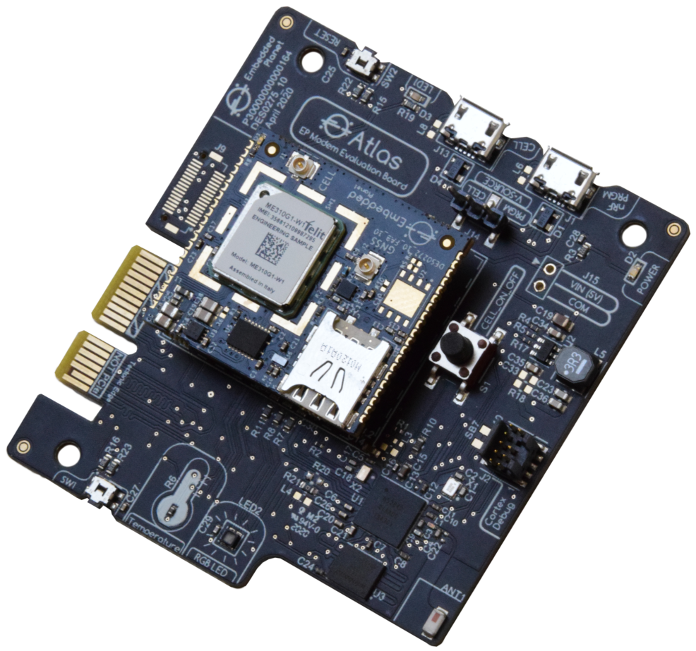

Introduction
The Embedded Planet Atlas development carrier board serves to demonstrate the functionality of the Embedded Planet Chronos Telit Module. It features an RGB LED and a thermistor temperature sensor. The platform can support data transport over BLE and Cellular.
Board functions are listed in the following table:
Feature | Description
Processor & BLE | nRF52840 – Cortex M4F 32-bit processor. This is the application processor and facilitates Bluetooth connectivity
Cellular Module | Embedded Planet Chronos Telit ME310
Temperature Sensor | Thermistor Circuit
NOR Flash | 25Q32JVIQ, 4 MB external QSPI NOR Flash
Debug | Tectonic Edge programming header and SWD populate option
LED | RGB LED
Power | 2 USB ports, and Tectonic Edge programming header
Connectivity | DF12-32 connector for integration with sensor boards from Tiny Circuits

Development
Atlas is in the process of becoming an Mbed Enabled target. It can currently be programmed via the SWD header and a Jlink programmer, or a Flidor programmer over Daplink, or via the USB port labelled nRF PRGM. Programming over USB requires use of the NRF CONNECT application and specially modified applications that work in conjunction with the Nordic USB bootloader.
https://www.nordicsemi.com/Products/Development-tools/nrf-connect-for-desktop/download#infotabs

Click here for detailed instructions regarding programming Atlas over USB
https://docs.embeddedplanet.com/docs/assets/Programming-Atlas-Over-USB.pdf

Flidor Development Interface Board
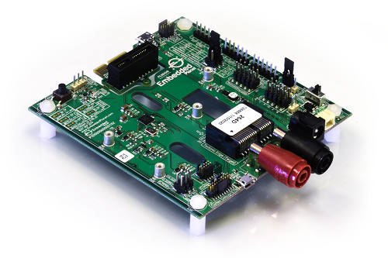
Atlas application development can be achieved with the use of the Flidor development interface board. Flidor is a programmer, debugger, and breakout interface for Tectonic Edge compatible target devices, such as Atlas. Flidor provides power to the target MCU and connects it to a computer via USB for debugging.
Click here for more information about Flidor

Customer Support
Embedded Planet provides complete support for our product line. Embedded Planet technical support includes product assistance for EP firmware and hardware. Technical support can assist with setup, installation, configuration, documentation, product related questions, and expansion guidelines.

Contact Embedded Planet
Embedded Planet
31225 Bainbridge Rd, Suite N
Solon, OH 44139
Phone:216.245.4180
Fax: 216.292.0561
www.embeddedplanet.com

Company Email
Sales: sales@embeddedplanet.com
Information Requests: info@embeddedplanet.com
Technical Support: support@embeddedplanet.com

Disclaimer

FCC NOTICE: This kit is designed to allow:

(1) Product developers to evaluate electronic components, circuitry, or software associated with the kit to determine whether to incorporate such items in a finished product and

(2) Software developers to write software applications for use with the end product. This kit is not a finished product and when assembled may not be resold or otherwise marketed unless all required FCC equipment authorizations are first obtained. Operation is subject to the condition that this product not cause harmful interference to licensed radio stations and that this product accept harmful interference. Unless the assembled kit is designed to operate under part 15, part 18 or part 95 of this chapter, the operator of the kit must operate under the authority of an FCC license holder or must secure an experimental authorization under part 5 of this chapter.
Last updated on 8/11/2020

