Chronos | Chronos Overview
3 Dec 2021 | v1.0.0

www.embeddedplanet.com

Contents
1. Introduction 3
2. Downloads 3
3. Specifications 3
4. Pinout 4
5. Atlas: Development Platform 5
6. Customer Support 6
a. Contact Embedded Planet 6
b. Company Email 6

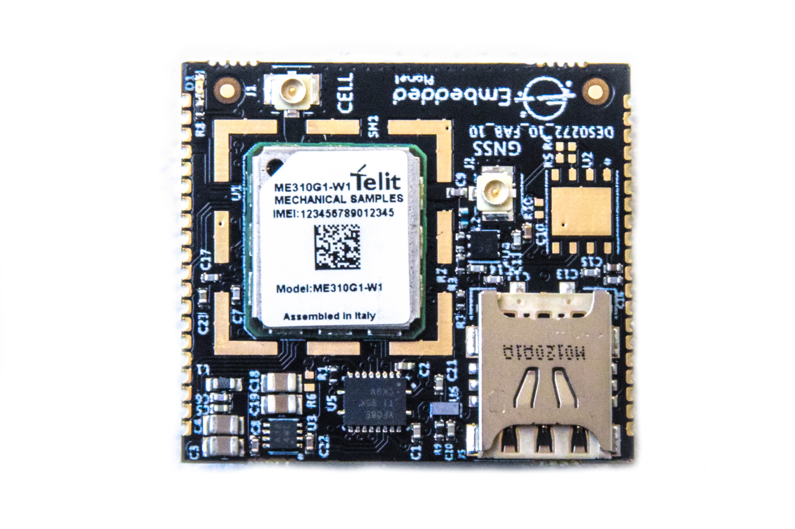
- Introduction
Chronos is a small form-factor modem for embedded cellular applications. A mere 29.5mm x 33mm in size, the Chronos module can be mounted using a standard 2×10-pin modem header or the module’s own castellated pads – perfect for streamlined integration into product designs. Chronos also supports GNSS for location tracking.
- Downloads
All other documentation & downloads pertaining to the Chronos module can be found at:
www.embeddedplanet.com/documentation
- Specifications
Specification | Description
Cellular | Cat-M1 (1.4MHz) / NB-IoT (NB2 200kHz)
SIM Size | 4FF / MFF2
Interface Options | Dual 10-pin header or SMT (castellated configuration)
Carrier Certifications | AT&T / Verizon
Dimensions | 29.5mm x 33mm
Antenna Interface | Cellular: 1 x U.FL / GNSS: 1 x U.FL
Data Interface | UART, USB 2.0 HS
I/O | UART, SPI, GPIO, I²S, ADC, DAC
Power | 3.8VDC nominal (I/O: 1.8V - 5.5V)
Operating Temperature | -40°C to +85°C

- Pinout

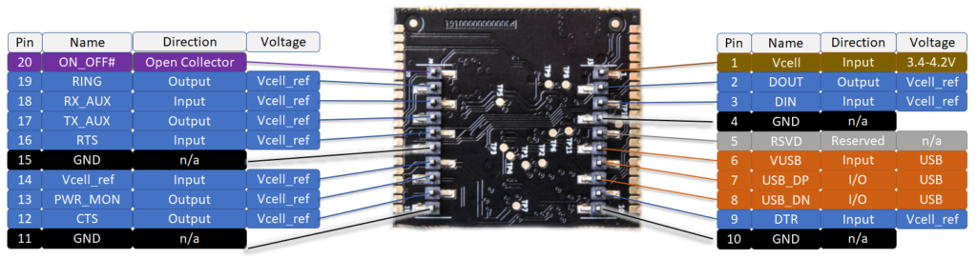

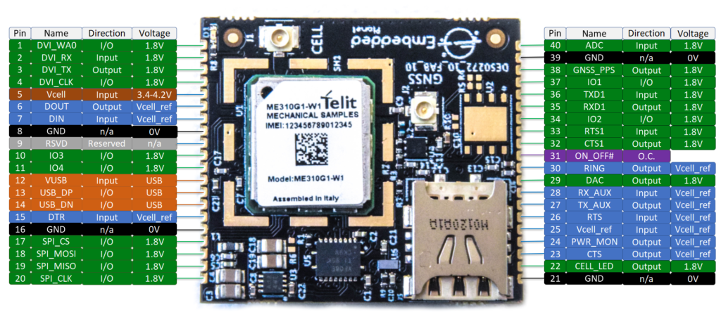

- Atlas: Development Platform
Embedded Planet offers the Atlas development board for rapid prototyping with the Chronos modem. Featuring an on-board nRF52840 the Atlas can be used to interface with and control the Chronos modem module. These two devices together make a functional development platform capable of performing as a programmable connected device.
The Atlas provides further useful on-board development functions such as a GPIO-controllable RGB LED, a temperature sensor, a general-purpose pushbutton, a dedicated GPIO-controlled red LED, Arm Cortex debug header, micro-USB interface, Tectonic Edge™ interface from Embedded Planet, DF-12 footprint, and more.

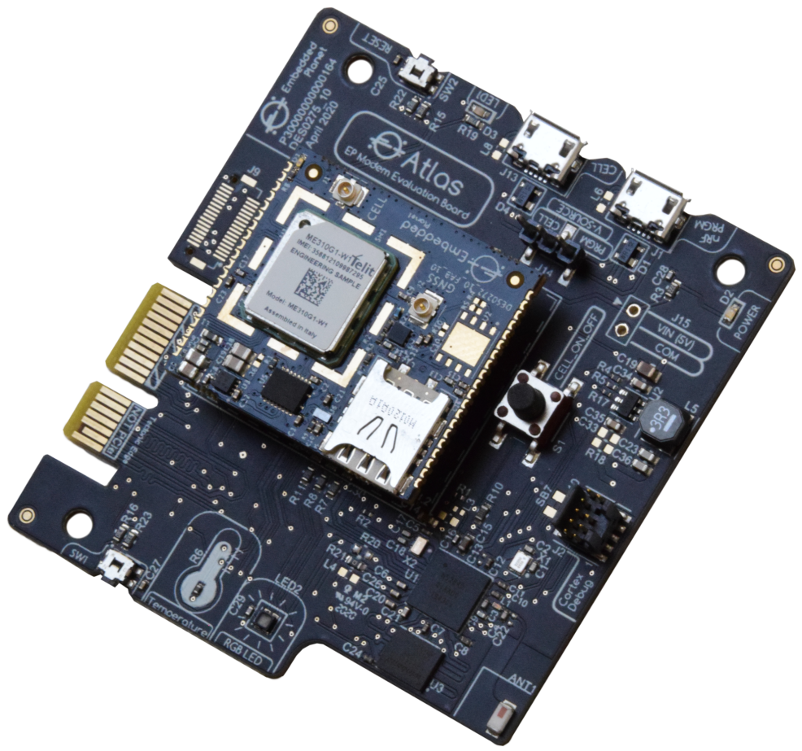

- Customer Support
Embedded Planet provides complete support for our product line. Embedded Planet technical support includes product assistance for EP firmware and hardware. Technical support can assist with setup, installation, configuration, documentation, product related questions, and expansion guidelines.

  - Contact Embedded Planet
Embedded Planet
4760 Richmond Road, Suite 400
Warrensville Heights, OH 44128
Phone:216.245.4180
Fax: 216.292.0561
www.embeddedplanet.com

  - Company Email
Sales: sales@embeddedplanet.com
Information Requests: info@embeddedplanet.com
Technical Support: support@embeddedplanet.com

