DES0258 Wireless Gateway - Development Guide

1. Introduction
The DES0258 Wireless Gateway is a robust solution to enable wireless connectivity in your system. With wireless configuration options available for WiFi, Cellular, Bluetooth, SmartMesh IP, and LoRa, the Wireless Gateway has many potential applications for bringing your system to the cloud. Additional connectivity options include ethernet, 1-wire, RS-232/RS-485, FlexCAN, USB-Host/USB-OTG, and various analog inputs. Onboard sensors such as Light, temperature, humidity, and accelerometer/magnometer provide the gateway with an environmental intelligence and ability to forgo the need for external hardware for basic sensing needs.

2.1 | Product Features
- MCIMX6G2DVM05AA 528MHz processor with ARM Cortex-A7 core
- Cat 1 / Cat M / NB-IoT
- Dual-band 802.11abgn Wi-Fi
- 802.15.4: SmartMesh IP or Thread
- Bluetooth 4.0/4.2/5
- 10/100 PHY on RMII and MDIO via RJ-45 with magnetics
- 1-wire via RJ-45
- RS-232 / RS-485
- 2 FlexCAN ports
- USB-A Host, USB-OTG
- Analog inputs
- PMIC with rechargeable coin cell battery backup
- 512MB x16 (1GB x 16 optional) DDR3L SDRAM
- 4GB eMMC
- 64MB QuadSPI NOR flash

2.2 | System Block Diagram
The Wireless Gateway is based on an ARM Cortex-A7 processor (MCIMX6G2DVM05AA) that interacts with each of the wireless connectivity modules as well as the PMIC, sensors, external memory, and direct USB connectors.
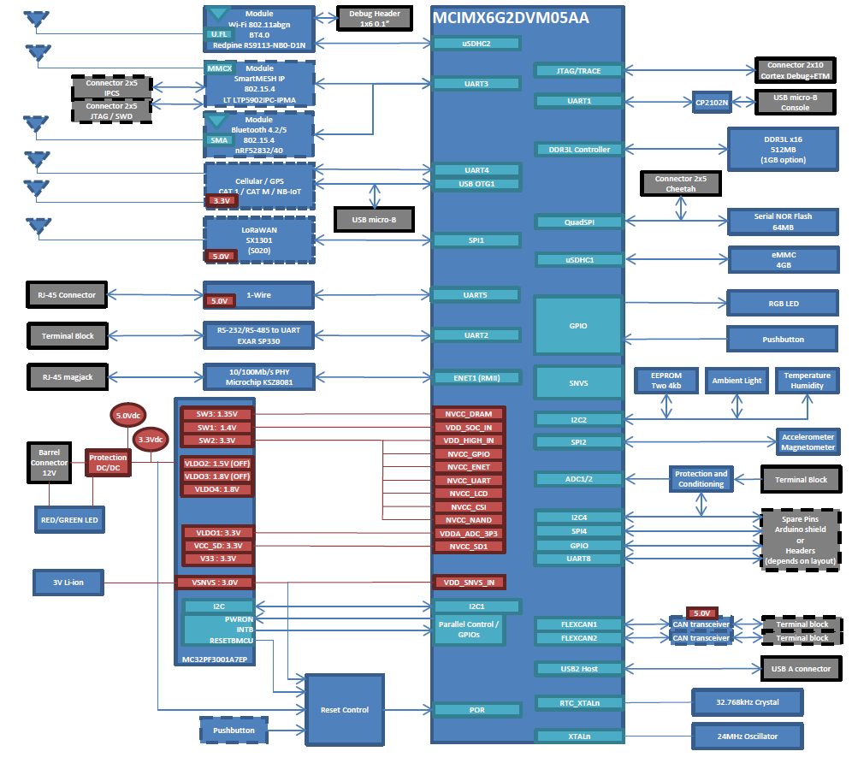
DES0258 Wireless Gateway Block Diagram

Functional Blocks
- 1-wire: LinkOEM module to RJ-45.
- 802.15.4: SmartMesh IP using Linear Tech LTP5902IPC-IPMA OR Thread / Zigbee using Nordic nRF52832 or nRF52840
- ADC: 8 channels, each independently configurable for one of the following inputs: Contact closure detection, Analog voltage measurement, 4-20mA current loop measurement. The analog switches can be configured such that any number of each of the three types of input (up to a total of eight inputs) can be supported.
- Bluetooth: Bluetooth 4.0 included on Redpine RS9113-NB0-D1N, Bluetooth 4.2 and Bluetooth 5.0 included on nRF528xx
- Cellular / GPS: Cat 1 / Cat M / NB-IoT, Telit data card LE910-xx1, mini PCI Express card
- Clocks: A 24MHz clock oscillator provides the CPU clock. A 32.768kHz crystal provides the RTC clock.
- DDR3L SDRAM: Standard DRAM is a 4Gb (256MBx16) DDR3L chip (Micron MT41K256M16TW-107:P). Optional DRAM population is a 8Gb (512MBx16) DDR3L chip (Micron MT41K512M16HA-125 IT:A).
- EEPROM: Two 4kb (512x8) serial EEPROMs on I2C (Microchip AT24C04C-XHM)
- Ethernet: 10Base-T/100Base-TX via Microchip KSZ8081, RJ-45 connector with magnetics.
- FlexCAN: 2 FlexCAN transceivers.
- LEDs: Red/Green LED, connected to PMIC power good signal, Connection and activity LEDs on RJ-45 connector, One user RGB LED.
- LoRaWAN: SX1301, as implemented in S020.
- MMC/SD: Standard eMMC is one 4GB chip (Micron MTFC4GACAJCN-4M IT); 4-bit mode supported.
- PMIC: Power management IC NXP MC32PF3001A7EP provides CPU power rails and sequencing.
- Processor: NXP MCIMX6G2DVM05AA - The processor pin mux is selected to support the required peripherals.
- Processor Debug Headers: ARM JTAG on a 20-pin (2x10), 0.05” pitch header. UART1 connected via a CP2102N UART-to-USB bridge to a USB micro-B connector for the console.
- Pushbuttons: One GPIO pushbutton.
- RS-232 / RS-485: Exar SP330 allows RS-232 and RS-485 (half and full duplex) with optional slew rate limiting, Function to controlled by DIP switches.
- Sensors:
- Light: Maxim MAX44009EDT+
- Temperature and Humidity: Silicon Labs Si7021-A10GM
- Accelerometer / Magnetometer: NXP FXOS8700CQR1
- Serial NOR Flash: 512Mb (64MBx8) of QPSI NOR flash, Cypress S25FL512SAGBHIC10.
- USB: USB host with A connector.
- Wi-Fi: 802.11abgn, Redpine RS9113-MB0-D1N

2.3 | Basic Operation
To boot up the device, it must be plugged in to its power source (barrel jack) with the power LED turning on to confirm the presence of power. The device will then run the software programmed onto it which will dictate the operation of the Status LED, wired/wireless connectivity, and sensor/analog inputs.

2. Processor
The Wireless Gateways uses a MCIMX6G2DVM05AA 528MHz processor with ARM Cortex-A7 core. Due to the required use of a pin mux and particular pin assignments, some specialty pins may not be available for use (see the notes on availability described in section 2.1). More information of the MCIMX6G2DVM05AA can be found in the "External References" section.

2.1 | Processor Specs

Processor
- The Wireless Gateways uses a MCIMX6G2DVM05AA 528MHz processor with ARM Cortex-A7 core.

CMOS Sensor Interface
- The CPU has one CSI (CMOS) interface which is not available due to the required pin mux.

DDR Memory Controller
- The CPU has one DDR memory controller which is connected to DDR3L SDRAM (see Memory section for more info).

Enhanced Period Interrupt Timer
- The CPU has two EPITs (Enhanced Period Interrupt Timer); Neither of the EPITs is available due to the required pin mux.

Ethernet Controller
- The CPU has two Ethernet controllers: ENET1 (RMII) is connected to a Microchip KSZ8081 10Base-T/100Base-TX PHY, ENET2 is unavailable due to the required pin mux.

External Interface Module
- The CPU has one EIM (External Interface Module); The EIM is not available due to the required pin mux.

FlexCAN
- The CPU has two FlexCAN interfaces. Both interfaces are connected to CAN transceivers.

GPIO
- The CPU has five banks of GPIO with up to 32 GPIO in each bank. Many of the GPIO are not available due to the required pin mux. Those that are available are connected to the expansion header.

General Purpose Timer
- The CPU has two GPTs; Neither of the GPTs is available due to the required pin mux.

I2C Interface
- The CPU has four I2C interfaces; I2C1 is connected to the PMIC, I2C2 is connected to EEPROM + Light sensor + Temperature / Humidity sensor, I2C3 is not available due to the required pin mux, and I2C4 is connected to an I2C to 8-bit port to control the analog switches (I2C4 is also connected to the expansion header). Neither of the EPITs is available due to the required pin mux.

Keypad Port
- The CPU has one KPP; The KPP is not available due to the required pin mux.

LCD Interface
- Due to the required pin mux, LCD interface is not available.

Quad Serial Peripheral Interface
- The CPU has one QSPI which is connected to serial NOR flash.

SDIO
- The CPU has two SDIO interfaces: µSDHC1 is connected to eMMC, and µSDHC2 is connected to the Wi-Fi / Bluetooth (BT) module.

Serial Peripheral Interface (SPI)
- The CPU has four ECSPI interfaces: ECSPI1 is connected to the SX1301 LoRaWAN module, ECSPI2 is connected to the Accelerometer / Magnetometer, ECSPI3 is unavailable due to the required pin mux, and ECSPI4 is connected to the expansion header.

UART
- The CPU has eight UARTs: UART1 is connected via a CP2102N UART to USB bridge to a micro-B USB connector for the console, UART2 is connected to an Exar SP330 RS-232/RS-485 transceiver, UART3 is connected to the 802.15.4 modules, UART4 is connected to the cellular module, UART5 is connected to the 1-wire module, UART6 is unavailable due to the required pin mux, UART7 is unavailable due to the required pin mux, UART8 is connected to the expansion header.

USB
- The CPU has two USB ports: USB1 is connected to the cellular module and a micro-AB connector (this connector is internal to the enclosure and is for factory use only). USB2 is a host connected to an A connector (this connector is exposed on the enclosure end plate).

Power
- Input power is derived from a 12V, 1.5A min supply. Power and sequencing to the CPU is supplied by the onboard PMIC. A coin cell provides the battery backup input to the PMIC.

Resets
- PMIC and other “Power Good” signals are used to generate resets for the CPU and other peripherals that require them. Manual reset is provided via a pushbutton.

2.2 | Processor Block Diagram
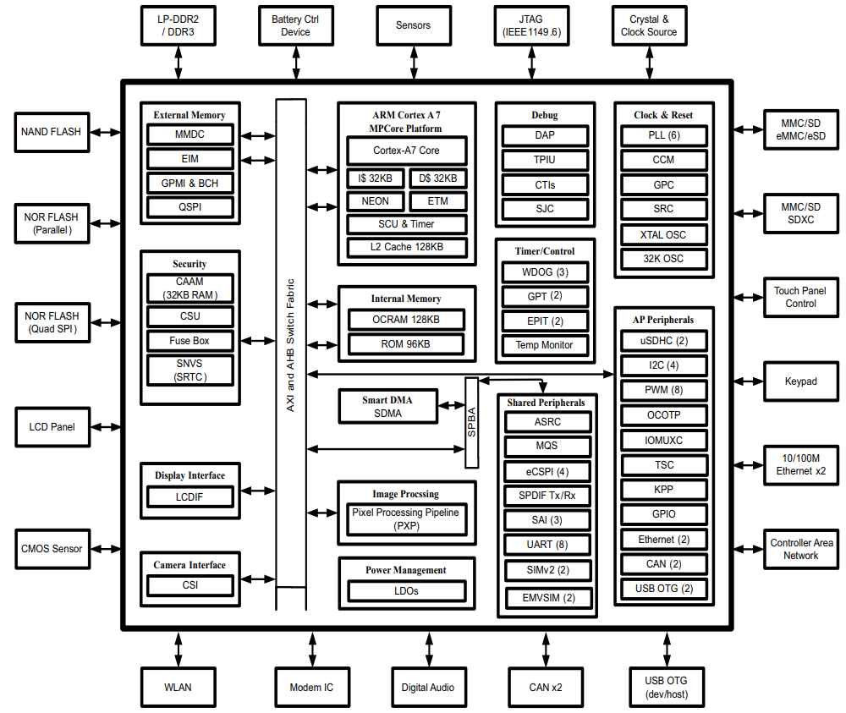i.MX 6UltraLite Block Diagram (NXP)

3. Wireless Connectivity
The DES0258 Wireless Gateway can support the following wireless connectivity configurations: Cellular, WiFi, SmartMesh IP (SMIP), Bluetooth, and GPS/GNSS.

3.1 | Cellular
Cat 1 / Cat M / NB-IoT

3.2 | Wifi
Dual-band 802.11abgn Wi-Fi

3.3 | SmartMesh IP (SMIP)
802.15.4: SmartMesh IP or Thread

3.4 | Bluetooth
1Bluetooth 4.0/4.2/5

3.5 | GPS/GNSS
Refer to cellular module. Dedicated antenna slot allocated for GPS/GNSS in back of product housing.

4. Wired Connectivity

4.1 | Ethernet
- 110/100 PHY on RMII and MDIO via RJ-45 with magnetics
- The CPU has two Ethernet controllers: ENET1 (RMII) is connected to a Microchip KSZ8081 10Base-T/100Base-TX PHY, ENET2 is unavailable due to the required pin mux.

4.2 | 1-Wire
- 1-wire via RJ-45

4.3 | Serial
- RS-232 / RS-485 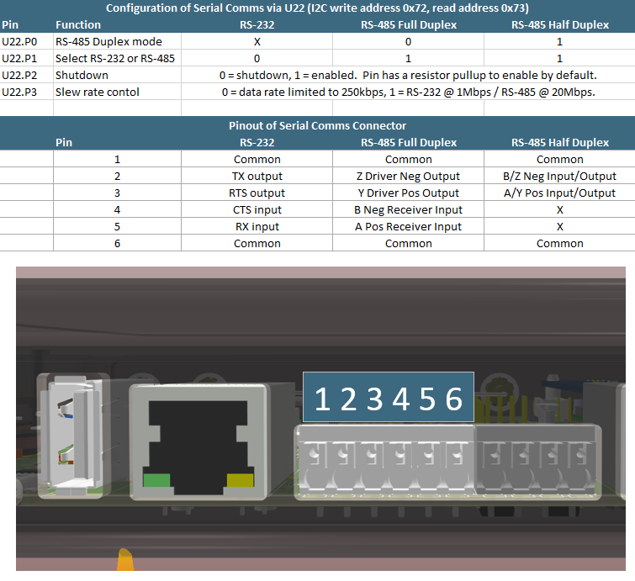 DES0258 Analog Inputs Table

4.4 | FlexCAN
- The CPU has two FlexCAN interfaces. Both interfaces are connected to CAN transceivers.

4.5 | USB
- USB-A Host
- USB-OTG (USB-micro_)

4.6 | Analog Inputs
- 4-20mA, 0-32V

5. Product Layout

5.1 | Sensors
- Temperature
- Humidity
- Accelerometer
- Magnometer

5.2 | Connectors
- Barrel Jack (power in)
- USB-A (Host)
- USB-micro (USB-OTG) (Console)
- Ethernet (RJ-45)
- RS232/485
- CAN1 (L&H)
- CAN2 (L&H)
- 1-Wire (RJ-45)
- Analog In channels 0-7 (+/- per channel)
- Wi-Fi antenna mount
- GNSS/diversity antenna mount
- Cellular antenna mount
- Wireless Sensor Network antenna mount (e.g. SMIP)

5.3 | Power
- 12v in via barrel jack
- PMIC with rechargeable coin cell battery backup

5.4 | LEDs
Two LEDs are present on the face of the Wireless Gateway to provide the user with information on the status of the device (Power LED and Status LED). The Power LED is on (solid) while the unit is powered and off when unpowered. The Status LED is programmable through the gateway's software.

5.5 | Pushbutton
"Mode" pushbutton featured on front of product casing.

5.6 | Analog Inputs
The CPU has two Analog-to-Digital converters. The ADCs share pins which are connected via analog switches to one of the three types of input as detailed in the ADC functional block diagram. The analog switches are software controlled.

5.6.1 | Reading Analog Inputs
The analog inputs are mapped to virtual files in the Linux filesystem. So, in order to read an analog input, you can simply read the contents of the corresponding virtual file. The return value is the raw ADC counts.
For example, to read the analog input on channel 0, you would cat the target virtual file:
cat /sys/bus/iio/devices/iio\:device0/in_voltage0_raw
To read a different channel, you simply replace the index with the target channel ID (e.g. for channel 1, use in_voltage1_raw).
See the following table mapping the analog input channels to the corresponding ID:
Input Channel | 0 | 1 | 2 | 3 | 4 | 5 | 6 | 7
Channel ID | 0 | 1 | 4 | 5 | 6 | 7 | 8 | 9
Type | Voltage | Voltage | Voltage | Voltage | 4-20mA | 4-20mA | 4-20mA | 4-20mA
For example, to read analog input channel 7, use the following command:
cat /sys/bus/iio/devices/iio\:device0/in_voltage9_raw

5.6.2 | Analog Input Calibration

5.6.2.1 | Voltage Inputs
The table below shows the comparison between the theoretical expected counts and actual counts for a voltage input reading.
Voltage Input (V) | Expected Counts | Counts | % Diff
0 | 0 | 46
0.576 | 58 | 73 | 25.86
1.053 | 105 | 110 | 4.76
2.562 | 256 | 258 | 0.78
3.845 | 385 | 391 | 1.56
4.987 | 499 | 507 | 1.60
10.08 | 1008 | 1025 | 1.69
15.04 | 1504 | 1527 | 1.53
20.06 | 2006 | 2038 | 1.60
24.99 | 2499 | 2542 | 1.72
30.02 | 3002 | 3055 | 1.77
32.02 | 3202 | 3259 | 1.78

Based on the data from the table above, the display voltage is calulcated as follows:
Display voltage = (counts * 0.986 -2) / 100
This gives better than 1.5% accuracy in the input range 1V to 32V.
Voltage Input (V) | Counts | Display Voltage (V)
0 | 46 | 0.43
0.576 | 73 | 0.70
1.053 | 110 | 1.06
2.562 | 258 | 2.52
3.845 | 391 | 3.84
4.987 | 507 | 4.98
10.08 | 1025 | 10.09
15.04 | 1527 | 15.04
20.06 | 2038 | 20.07
24.99 | 2542 | 25.04
30.02 | 3055 | 30.10
32.02 | 3259 | 32.11
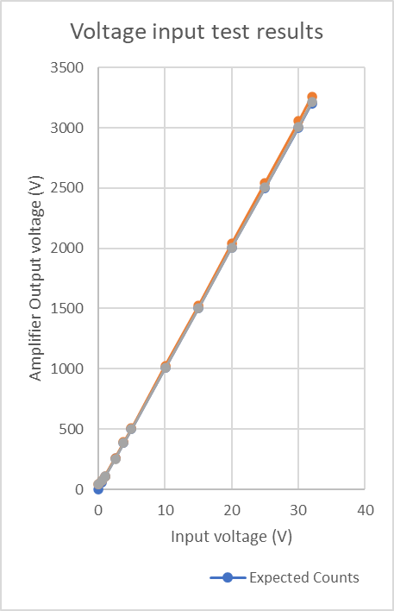

5.6.2.2 | 4-20mA Inputs
The table below shows the comparison between the theoretical expected counts and actual counts for a 4-20mA input reading.
Current Input (mA) | Expected Counts | Counts | % Diff
0 | 0 | 0
1.1 | 205 | 202 | -1.46
2.18 | 406 | 408 | 0.49
4.5 | 838 | 847 | 1.07
10.34 | 1925 | 1949 | 1.25
12.1 | 2253 | 2294 | 1.82
15.26 | 2841 | 2898 | 2.01
20.28 | 3776 | 3851 | 1.99
22.36 | 4163 | 4095 | -1.63
Based on the data from the table above, the display current is calculated as follows:
Display current = (counts * 0.985) / 186.25
This gives better than 0.5% accuracy in the 4-20mA input range.
Current Input (mA) | Counts | Display Current (mA)
0 | 0 | 0
1.1 | 202 | 1.07
2.18 | 408 | 2.16
4.5 | 847 | 4.48
10.34 | 1949 | 10.31
12.1 | 2294 | 12.13
15.26 | 2898 | 15.33
20.28 | 3851 | 20.37
22.36 | 4095 | 21.66

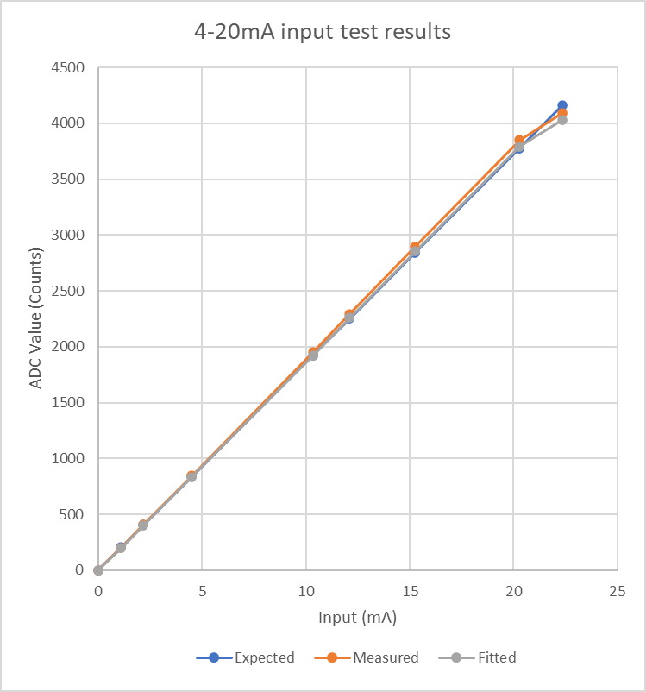

6. Memory
The CPU has one DDR memory controller which is connected to DDR3L SDRAM (see Memory section for more info).

6.1 | DDR3L
512MB x16 (1GB x 16 optional) DDR3L SDRAM

6.2 | eMMC
4GB eMMC

6.3 | NOR flash
64MB QuadSPI NOR flash

6.4 | EEPROM
Two 4kb (512x8) serial EEPROMs on I2C (Microchip AT24C04C-XHM)

7. Linux Console Utilities

7.1 | Das U-Boot-2016.09

8. Mechanical Specifications

8.1 | Environmental Considerations
- RoHS compliant
- Operating temperature range: 0°C to 40°C.
- Rated to UL 94V-0 Flammability Standard and marked “94V-0”.

8.2 | Mounting Considerations
- Designed to fit in Polycase ZN-40 enclosure
- Mounting holes provided to fit Polycase ZN-40 enclosure
- Non-RF connectors are edge aligned on one long edge of product with RF connectors all on the other side
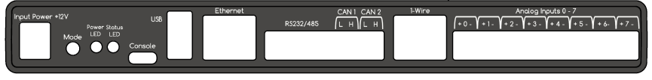DES0258 Front Panel (model)
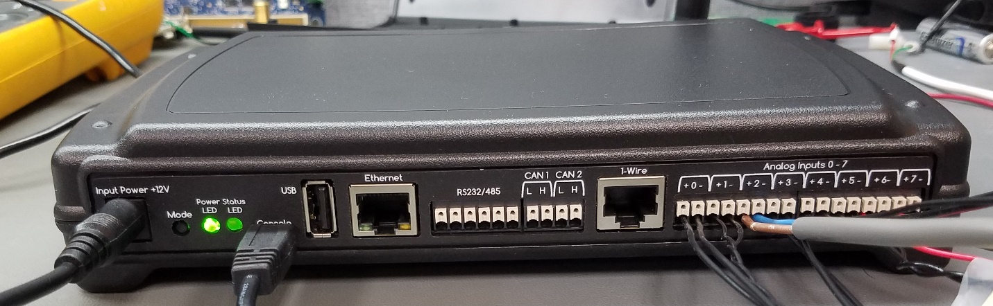DES0258 Front Panel (actual)
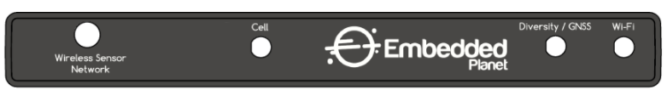DES0258 Rear Panel (model)
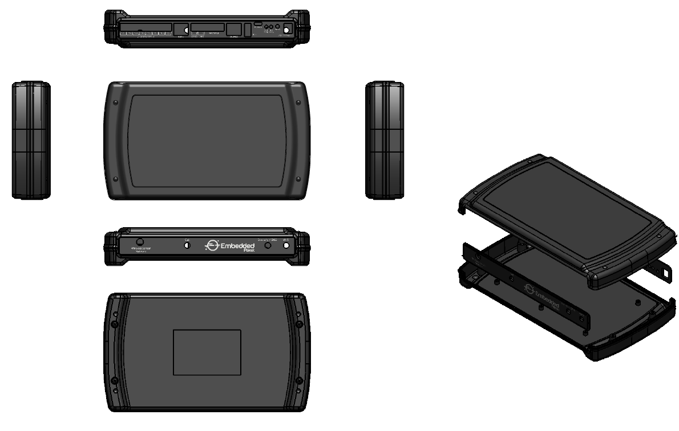 *DES0258 Assembly*

9. External References
- i.MX 6UltraLite Datasheet
- i.MX 6UltraLite Reference Manual
- i.MX 6UltraLite Hardware User's Guide

Customer Support
Embedded Planet provides complete support for our product line. Embedded Planet technical support includes product assistance for EP firmware and hardware. Technical support can assist with setup, installation, configuration, documentation, product related questions, and expansion guidelines.

Contact Embedded Planet
Embedded Planet
4760 Richmond Road, Suite 400
Warrensville Heights, OH 44128
Phone:216.245.4180
Fax: 216.292.0561
www.embeddedplanet.com

Company Email
Sales: sales@embeddedplanet.com
Information Requests: info@embeddedplanet.com
Technical Support: support@embeddedplanet.com

Copyright
Copyright © 2020 Embedded Planet, Inc. All Rights Reserved. This manual is copyrighted by Embedded Planet, Inc. No part of this document may be copied or reproduced in any form or by any means without the express written permission of Embedded Planet, Inc.

Notice
Embedded Planet, Inc., reserves the right to modify the information contained herein as necessary. Embedded Planet assumes no responsibility for any errors which may appear in this document. Information in this document is provided solely to enable system and software implementers to use Embedded Planet products.

Trademarks
Embedded Planet, Linux Planet, Blue Planet, RPX LITE, and RPX LICC are trademarks or registered trademarks of Embedded Planet.
All other names and trademarks are the property of their respective owners and are hereby acknowledged.
Last updated on 5/17/2021

