Flidor | Development Board for Embedded Planet Platforms
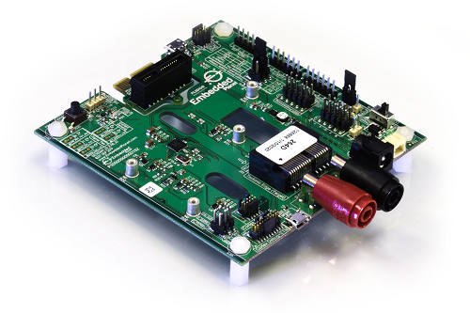

Overview
Flidor is a programmer, debugger, and breakout interface for Tectonic Edge™ compatible target devices. The Flidor board includes a DAPlink interface featuring a K20DX microcontroller, allowing the Flidor to power a target MCU and connect it to a computer via USB for debugging. The Flidor board not only breaks out all the pins of the target device’s Tectonic Edge™ connector but can also connect to devices for programming/debugging through the Cortex Debug/+ETM pins. Flidor can be powered over USB, banana jacks, DC barrel jacks, and more. Additionally, Flidor features various options for mounting and orientation in which you can connect Tectonic Edge devices.
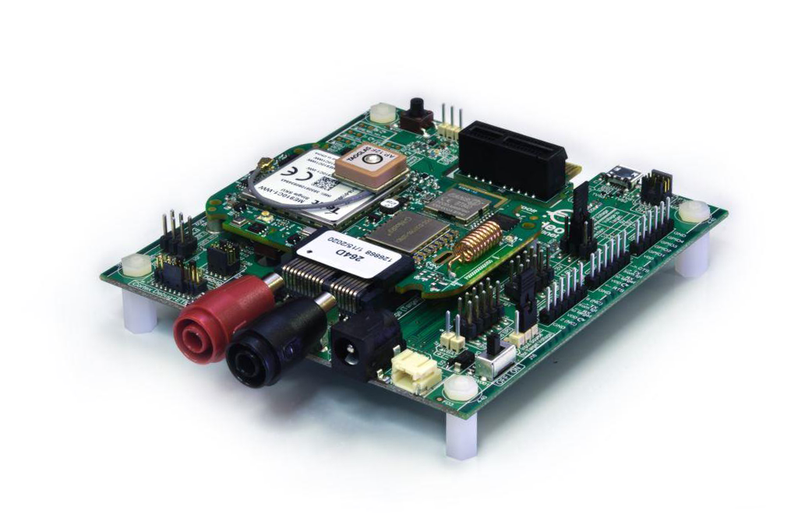
Flidor board with Agora connected
Find out more about the Flidor development board here.
Last updated on 11/10/2020

