Tectonic Edge Overview
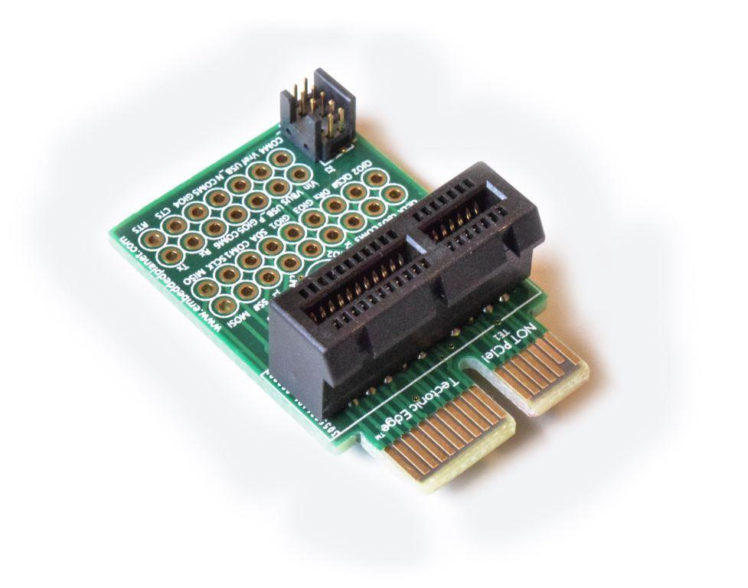

Introduction
Tectonic Edge is the name of Embedded Planet's custom connection ecosystem that accomodates both board-to-board connectivity and debug & programming functionality. This ecosystem provides many connection options though the use of various adapters, allowing the user to tap into key data and power lines of a product with a minimal footprint. The Tectonic Edge ecosystem uses a PCIe physical format, but is NOT pin compatible with actual PCIe devices. Never use actual PCIe devices in combination with Tectonic Edge devices.

Downloads
- Tectonic Edge Through-Hole Adapter | Drawings Compilation
- Tectonic Edge Terminal Block Adapter | Drawings Compilation
- Tectonic Edge Right Angle Adapter (feature of Flidor board)| Dimensional Information
- Tectonic Edge Board Edge Fingers | Drawing Information
- Tectonic Edge Adapter Mounting Example | Drawing Information (Flidor used as example with right angle adapter)

Supported Boards
Below is a list of products from Embedded Planet that support the Tectonic Edge ecosystem

Atlas
- Atlas | Docs Page
- Atlas | Shop Page
- Atlas (kit) | Shop Page

Agora
- Agora | Product Page
- Agora | Docs Page
- Agora | Shop Page
- Agora + Flidor (kit) | Shop Page

Tectonic Edge Accessories
- Tectonic Edge Right Angle Adapter (feature of Flidor board)| Shop Page
- Tectonic Edge Through-Hole Adapter | Shop Page
- Tectonic Edge Terminal Block Adapter | Shop Page

Generalized Pinout
Top:
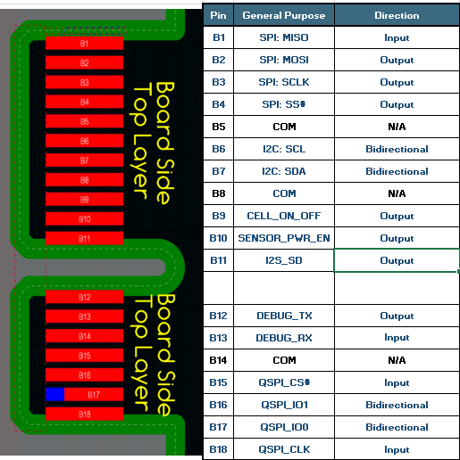

Bottom:
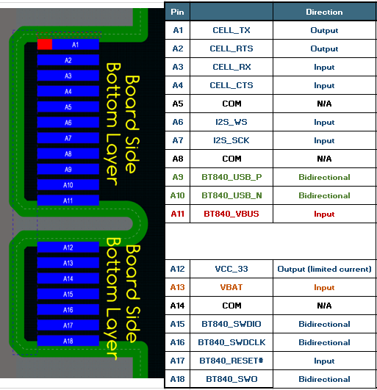

Customer Support
Embedded Planet provides complete support for our product line. Embedded Planet technical support includes product assistance for EP firmware and hardware. Technical support can assist with setup, installation, configuration, documentation, product related questions, and expansion guidelines.

Contact Embedded Planet
Embedded Planet
4760 Richmond Road, Suite 400
Warrensville Heights, OH 44128
Phone:216.245.4180
Fax: 216.292.0561
www.embeddedplanet.com

Company Email
Sales: sales@embeddedplanet.com
Information Requests: info@embeddedplanet.com
Technical Support: support@embeddedplanet.com
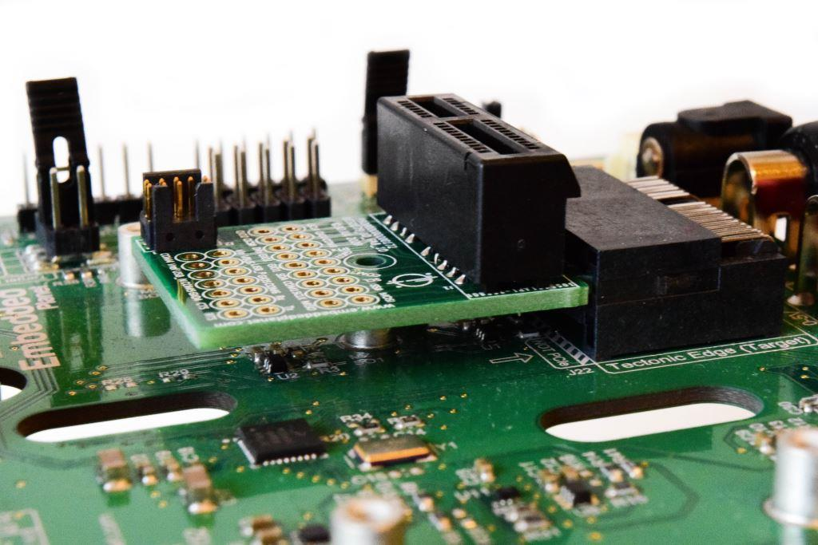
Last updated on 6/28/2021

